**Batch: A3 Roll No.: 16010121045**

**Experiment No. 1**

**Grade: AA / AB / BB / BC / CC / CD /DD**

|  |
| --- |
| **Title:**  Implementation of Abstract Data Type |

**Objective:** Implementation of ADT without using any standard library function

**Expected Outcome of Experiment:**

|  |  |
| --- | --- |
| **CO** | **Outcome** |
| **CO 1** | Explain the different data structures used in problem solving. |

**Books/ Journals/ Websites referred:**

**https://www.geeksforgeeks.org/abstract-data-types/**

**Abstract**:-

*(Define ADT. Why are they important in data structures?)*

**Abstract Data type (ADT)** is a type (or class) for objects whose behaviour is defined by a set of values and a set of operations. The definition of ADT only mentions what operations are to be performed but not how these operations will be implemented. It does not specify how data will be organized in memory and what algorithms will be used for implementing the operations. It is called “**abstract**” because it gives an implementation- independent view. The process of providing only the essentials and hiding the details is known as **abstraction**.

They are important in data structures because of the following reasons:

● Representation Independence: Most of the program becomes independent of the abstract data type's representation, so that representation can be improved without breaking the entire program.

● Modularity: With representation independence, the different parts of a program become less dependent on other parts and on how those other parts are implemented.

● Interchangeability of Parts: Different implementations of an abstract data type may have different performance characteristics. With abstract data types, it becomes easier for each part of a program to use an implementation of its data types that will be more efficient for that particular part of the program.

**Abstract Data Type for Rational Numbers**

*[for chosen data type write value definition and operator definition)*

**rationalclass.h**

*#ifndef* RATIONALCLASS_H

*#define* RATIONALCLASS_H

*#include* <stdbool.h>

class rational

{

public:

*// Constructors*

rational(void);

rational(int *N*, int *D*);

*// Set the value. Fails if D is not natural*

bool Set(int *N*, int *D*);

*// Functions*

rational Add(rational *OtherOne*);

rational Subtract(rational *OtherOne*);

rational Multiply(rational *OtherOne*);

rational Divide(rational *OtherOne*);

rational Simplify();

*// Read. Fails if D is not natural*

bool Read(void);

*// Write*

void Write(void);

private:

int Numerator,

Denominator;

};

*#endif*

**rationalclass.cpp**

*#include* <bits/stdc++.h>

*#include* "rationalclass.h"

using namespace std;

*// Constructors*

rational::rational(void)

{

Set(0, 1);

}

rational::rational(int *N*, int *D*)

{

Set(*N*, *D*);

}

*// Set the value. Fails if D is not natural*

bool rational::Set(int *N*, int *D*)

{

*if* (*D* >= 1)

{

Numerator = *N*;

Denominator = *D*;

*return* (true);

}

*else*

*return* (false);

}

*// Add*

rational rational::Add(rational *OtherOne*)

{

rational Answer;

Answer.Set(Numerator * *OtherOne*.Denominator + Denominator * *OtherOne*.Numerator,

Denominator * *OtherOne*.Denominator);

*return* (Answer);

}

*// Substraction*

rational rational::Subtract(rational *OtherOne*)

{

rational Answer;

Answer.Set(Numerator * *OtherOne*.Denominator - Denominator * *OtherOne*.Numerator,

Denominator * *OtherOne*.Denominator);

*return* (Answer);

}

*// Multiplication*

rational rational::Multiply(rational *OtherOne*)

{

rational Answer;

Answer.Set(Numerator * *OtherOne*.Numerator,

Denominator * *OtherOne*.Denominator);

*return* (Answer);

}

*// Division*

rational rational::Divide(rational *OtherOne*)

{

rational Answer;

Answer.Set(Numerator * *OtherOne*.Denominator,

Denominator * *OtherOne*.Numerator);

*return* (Answer);

}

*// Read. Fails if D is not natural*

bool rational::Read(void)

{

int NewNumerator,

NewDenominator;

cin >> NewNumerator >> NewDenominator;

*return* (Set(NewNumerator, NewDenominator));

}

*// Write*

void rational::Write(void)

{

int gcd = __gcd(Numerator, Denominator);

cout << Numerator / gcd << "/" << Denominator / gcd;

}

**useRational.cpp**

*#include* <bits/stdc++.h>

*#include* "rationalclass.h"

*#include* "rationalclass.cpp"

using namespace std;

int main(void)

{

rational R1,

R2,

Sum,

Multi,

Sub,

Divide;

cout << "Enter N and D for new R1 :";

*if* (!R1.Read())

cout << "Doh, must have a positive denominator" << endl;

cout << "Enter N and D for new R2 :";

*if* (!R2.Read())

cout << "Doh, must have a positive denominator" << endl;

cout << "R1 is ";

R1.Write();

cout << " and R2 is ";

R2.Write();

cout << endl;

Sum = R1.Add(R2);

cout << "Sum is ";

Sum.Write();

cout << endl;

Sub = R1.Subtract(R2);

cout << "Subtraction is ";

Sub.Write();

cout << endl;

Multi = R1.Multiply(R2);

cout << "Multiplication is ";

Multi.Write();

cout << endl;

Divide = R1.Divide(R2);

cout << "Division is ";

Divide.Write();

cout << endl;

*return* (0);

}

**Abstract Data Type for String and String Functions**

**pstring.h**

*#ifndef* RATIONALCLASS_H

*#define* RATIONALCLASS_H

*#include* <stdbool.h>

class pstring

{

public:

*// Constructors*

pstring(void);

pstring(char \**s*);

*// String Functions*

int length(void);

void concat(pstring *s1*, pstring *s2*);

void copy(pstring *s*);

bool compare(pstring *s*);

*// display*

void display(void);

*// Read*

void Read(void);

*// Setter*

void Set(char \**s*, int *len*);

private:

char str[1000];

int len;

};

*#endif*

**pstring.cpp**

*#include* <bits/stdc++.h>

*#include* "pstring.h"

using namespace std;

*// Constructors*

pstring::pstring(void){

char temp[1000];

Set(temp,0);

}

pstring::pstring(char* *s*){

int c=0;

*while*(str[c]!='\0')

c++;

Set(*s*,c);

}

*// Setter*

void pstring::Set(char* *s*,int *l*){

*for*(int i=0;i<*l*;i++)

str[i]=*s*[i];

len=*l*;

}

*// length*

int pstring::length(){

*return* len;

}

*// Concatenate*

void pstring::concat(pstring *s1*,pstring *s2*){

char temp[*s1*.len+*s2*.len];

*for*(int i=0;i<*s1*.len;i++)

temp[i]=*s1*.str[i];

*for*(int i=*s1*.len;i<*s1*.len+*s2*.len;i++)

temp[i]=*s2*.str[i-*s1*.len];

Set(temp,*s1*.len+*s2*.len);

}

*// Copy*

void pstring::copy(pstring *s1*){

Set(*s1*.str,*s1*.len);

}

bool pstring::compare(pstring *s1*){

*if*(len==*s1*.len)

{

*for*(int i=0;i<len;i++)

*if*(*s1*.str[i]!=str[i])

*return* false;

*return* true;

}

*return* false;

}

*// Display*

void pstring::display(void){

*for*(int i=0;i<len;i++)

cout<<str[i];

}

*// Read*

void pstring::Read(void){

char temp[1000];

cin>>temp;

int c=0;

*while*(temp[c]!='\0')

c++;

Set(temp,c);

}

**Useptring.cpp**

*#include* <bits/stdc++.h>

*#include* "pstring.h"

*#include* "pstring.cpp"

using namespace std;

int main(void) {

pstring str1,str2,str3,str4;

cout << "Enter String1: ";

str1.Read();

cout << "Enter String2: ";

str2.Read();

str1.display();

cout<<" length is "<<str1.length()<<endl;

str2.display();

cout<<" length is "<<str2.length()<<endl;

str3.concat(str1,str2);

cout<<"The concatenation is: ";

str3.display();

cout<<endl;

str4.copy(str1);

cout<<"Copied String1 To String4: ";

str4.display();

cout<<endl;

cout<<"Comparing String1 and String4"<<endl;

*if*(str1.compare(str4))

cout<<"The are equal"<<endl;

*else*

cout<<"They are not equal"<<endl;

cout<<"Comparing String2 and String4"<<endl;

*if*(str2.compare(str4))

cout<<"The are equal"<<endl;

*else*

cout<<"They are not equal"<<endl;

*return*(0);

}

**Abstract Data Type for Complex Numbers**

**compnumclass.h**

*#ifndef* COMPNUMCLASS_H

*#define* COMPNUMCLASS_H

*#include* <stdbool.h>

class compnum

{

public:

*// Constructors*

compnum(void);

compnum(double *r*, double *i*);

*// Set the value*

bool Set(double *r*, double *i*);

*// Functions*

compnum Add(compnum *OtherOne*);

compnum Subtract(compnum *OtherOne*);

compnum Multiply(compnum *OtherOne*);

compnum Divide(compnum *OtherOne*);

*// Read*

bool Read(void);

*// Write*

void Write(void);

private:

double real, img;

};

*#endif*

**compnumclass.cpp**

*#include* <bits/stdc++.h>

*#include* "compnumclass.h"

using namespace std;

*// Constructors*

compnum::compnum(void)

{

Set(0, 0);

}

compnum::compnum(double *r*, double *i*)

{

Set(*r*, *i*);

}

*// Set the value. Fails if D is not natural*

bool compnum::Set(double *r*, double *i*)

{

real = *r*;

img = *i*;

*return* true;

}

*// Add*

compnum compnum::Add(compnum *OtherOne*)

{

compnum Answer;

Answer.Set(real + *OtherOne*.real, img + *OtherOne*.img);

*return* (Answer);

}

*// Substraction*

compnum compnum::Subtract(compnum *OtherOne*)

{

compnum Answer;

Answer.Set(real - *OtherOne*.real, img - *OtherOne*.img);

*return* (Answer);

}

*// Multiplication*

compnum compnum::Multiply(compnum *OtherOne*)

{

compnum Answer;

double tempr = (real * *OtherOne*.real) - (img * *OtherOne*.img);

double tempi = (real * *OtherOne*.img) - (img * *OtherOne*.real);

Answer.Set(tempr, tempi);

*return* (Answer);

}

*// Division*

compnum compnum::Divide(compnum *OtherOne*)

{

compnum Answer;

double den = (*OtherOne*.real * *OtherOne*.real) + (*OtherOne*.img * *OtherOne*.img);

double tempr = (real * *OtherOne*.real) + (img * *OtherOne*.img);

double tempi = (img * *OtherOne*.real) - (real * *OtherOne*.img);

Answer.Set(tempr / den, tempi / den);

*return* (Answer);

}

*// Read. Fails if D is not natural*

bool compnum::Read(void)

{

double tempr, tempi;

cin >> tempr >> tempi;

*return* (Set(tempr, tempi));

}

*// Write*

void compnum::Write(void)

{

cout << endl

<< "Real Part is: " << real << " Imaginary Part is: " << img << "i" << endl;

}

**usecompnum.cpp**

*#include* <bits/stdc++.h>

*#include* "compnumclass.h"

*#include* "compnumclass.cpp"

using namespace std;

int main(void)

{

compnum N1, N2, Sum, Multi, Sub, Divide;

cout << "Enter Real and Imaginary for new N1 : ";

*if* (!N1.Read())

cout << "Something went wrong" << endl;

cout << "Enter Real and Imaginary for new N2 : ";

*if* (!N2.Read())

cout << "Something went wrong" << endl;

cout << "N1 is ";

N1.Write();

cout << "N2 is ";

N2.Write();

cout << endl;

Sum = N1.Add(N2);

cout << "Sum is ";

Sum.Write();

cout << endl;

Sub = N1.Subtract(N2);

cout << "Subtraction is ";

Sub.Write();

cout << endl;

Multi = N1.Multiply(N2);

cout << "Multiplication is ";

Multi.Write();

cout << endl;

Divide = N1.Divide(N2);

cout << "Division is ";

Divide.Write();

cout << endl;

*return* (0);

}

**Implementation Details:**

**1. Enlist all the Steps followed and various options explored**

**Ans**: Learnt the use of structure implementation , Operator Overloading, ,Object concepts, etc. Most importantly, leant Abstract Data Types aka ADT with the comparer function the assigned data type.

**2. Explain your program logic and methods used.**

**Ans:** The Rational ADT takes in two values and performs basic mathematical operations on it using the following methods:

* **bool Set(int N, int D):** Sets the given values for numerator and denominator
* **rational Add(rational OtherOne) :** Adds two rational numbers
* **rational Subtract(rational OtherOne) :** Subtracts two rational numbers
* **rational Multiply(rational OtherOne) :** Multiplies two rational numbers
* **rational Divide(rational OtherOne)** : Divides two rational numbers
* **rational Simplify() :** Simplifies the given rational number
* **bool Read(void):** Reads the input values from the user
* **void Write(void):** Displays/Prints the value stored in the object

The String(Pstring) ADT takes in one value i.e character array and performs basic string functions on it using the following methods:

* **int length(void):** Returns the length of the string object.
* **void concat(pstring s1, pstring s2):** Concatenates two given strings and stores it inside the object of the third string.
* **void copy(pstring s):** Copies given string and stores it inside the object of the respective string.
* **bool compare(pstring s):** Returns true or false based on if the given string is equal to the string object.
* **void display(void):** Displays the string object
* **void Read(void):** Reads the String from the user
* **void Set(char *s, int len):** Sets the string to given character array and also stores it’s length.

The Complex Number ADT takes in two values i.e Real numbers and Imaginary Number and performs basic mathematical operations on it using the following methods:

* **bool Set(double r, double i):** Sets the given values for real and imaginary
* **complex Add(complex OtherOne) :** Adds two complex numbers
* **complex Subtract(complex OtherOne) :** Subtracts two complex numbers
* **complex Multiply(complex OtherOne) :** Multiplies two complex numbers
* **complex Divide(complex OtherOne)** : Divides two complex numbers
* **bool Read(void):** Reads the input values from the user
* **void Write(void):** Displays/Prints the value stored in the object

**3. Explain the Importance of the approach followed by you.**

**Ans**: The approach of creating a rational number is important because we learnt using

ADT to implement different types of data structures by defining a set of functions or rules operating on them. We can use this concept to create more alike data types. The same goes for the Pstring (String) ADT which was created.

**Program code and Output screenshots:**

**Rational Number**

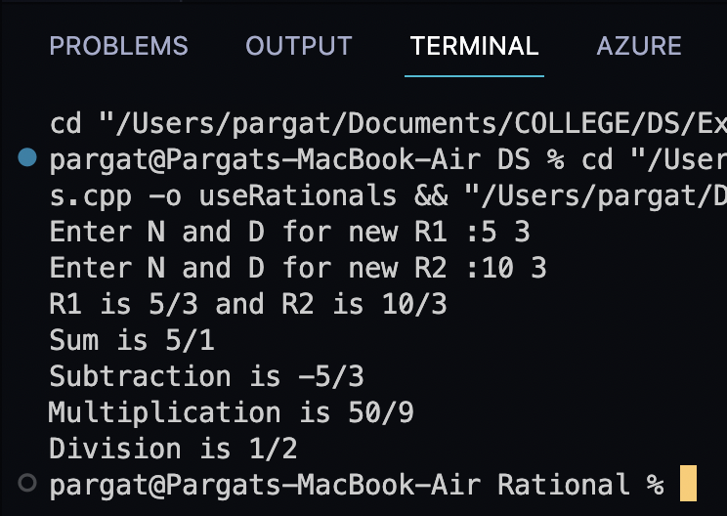

**String ADT**

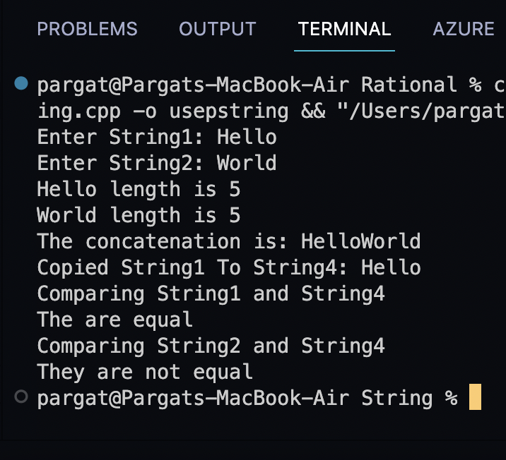

**Complex Numbers**

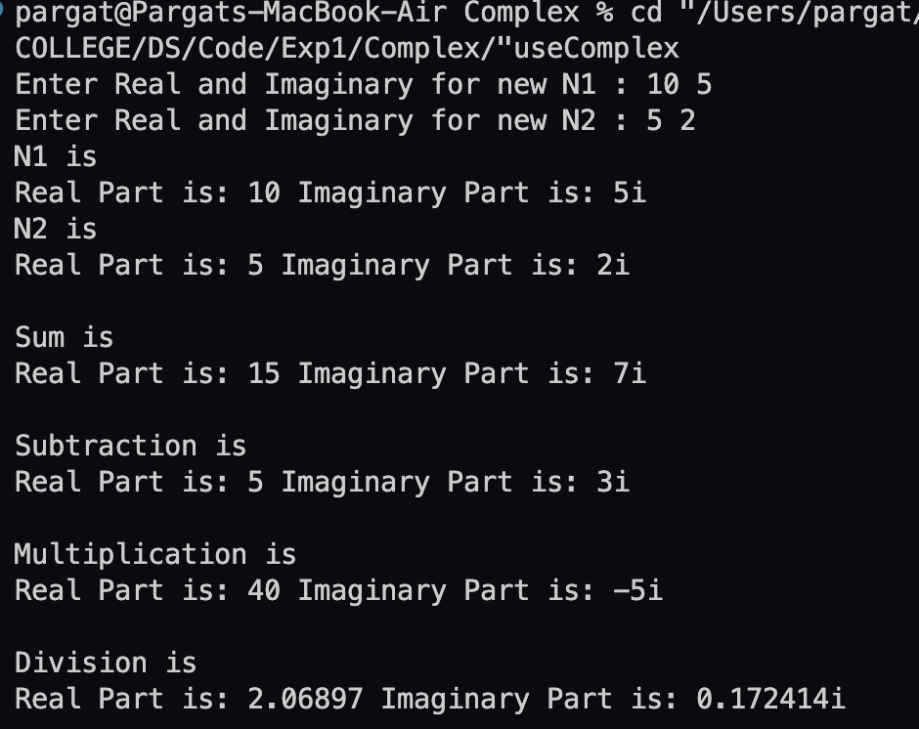

**Conclusion:-**

Hence Abstract Data Type is implemented and learnt using Rational Numbers, String functions and Complex Numbers ADT.